Hub & Spoke / Bump & Grind Cycling Route

Route Name
Euroa – Arboretum Loop

Mode:
Gravel Grinder, mountain bike, hybrid, eBike

Start / Finish locations:
Euroa Railway Station Railway St., Euroa 3666
- Straight off the train, start at the station
- Arriving by car, park in Railway St. to start

Map:

GPS -36.749156, 145.568173
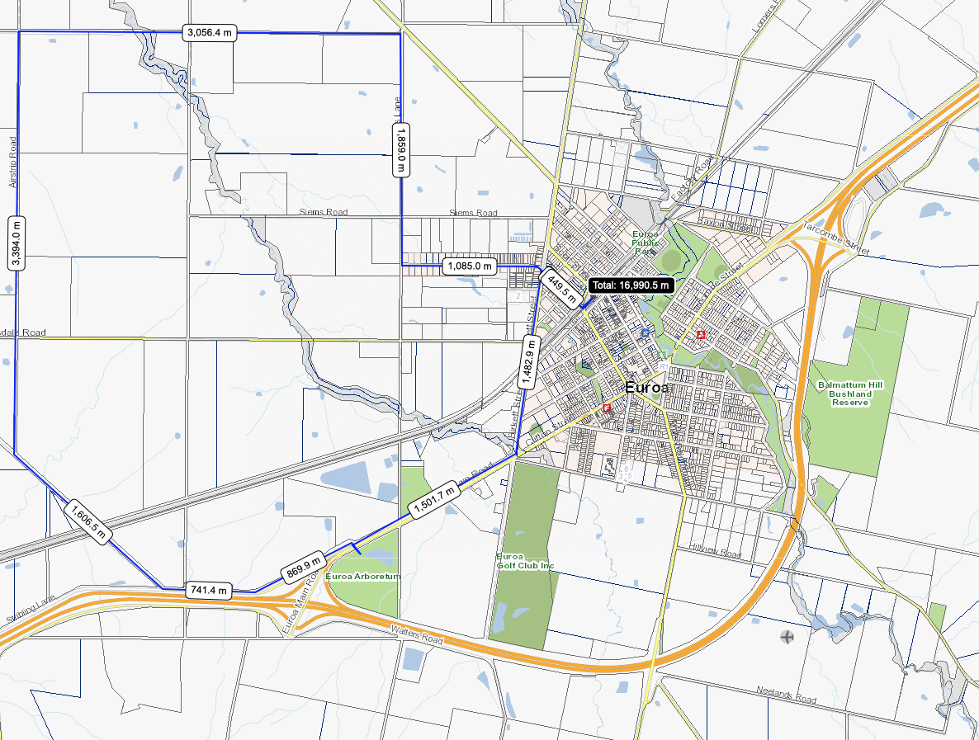

Difficulty:
Easy – intermediate (not for road bikes)

Distance and time:
17km. 1 – 2hrs.

Elevation:
163 – 202m
Topography:
Flat with one small rise.

Surfaces:
- Good condition bitumen, with a nice wide shoulder on the Euroa – Main Rd return section
- Good condition gravel.
- Airstrip and Earnshaw Roads are two wheel dirt tracks which may be rutted. They have some dust drifts in summer, muddy in the wet.

Description and Features:
A ride from the sedate, urban areas of rural Euroa Township into the surrounding plains country. Flat expanses of cropping and grazing lands, with Strathbogie Tablelands as a backdrop. Wooded roadside vegetation. Many fine rural properties. A sad looking local airstrip. Large scale free range chicken farms.

Take a break at the excellent locally indigenous Arboretum. There are a few Km extra of intertwining bushland tracks to enjoy. Other amenities include shelter, picnic facilities, public art, wetlands, a bird hide, a small lake and the site supplied nursery is well worth your perusal.

Riding conditions:
Minimal gradients. Very little traffic. Exposed to the elements.

Options:
It is about 3.5km (7km return) to the Euroa Arboretum via the Euroa – Main Rd.
Anti or clockwise

Anticlockwise Cues:
From the Euroa Railway Station
Right Scott St
Left Elliot St
Right De Boos St
Straight Branjee Rd
Right Cowells Lane
Left Wood Rd
Left Airstrip Rd
Straight Earnshaw Rd
Left Angle Rd
Opposite Euroa Arboretum entry
Straight Euroa – Main Rd
Left Birkett St
Right Handbury St
Right Elliot St
Right Scott St
Left Euroa Railway Station

Amenities (in Euroa):
Car parking
BBQ
Fuel
Shops
Seating
Parkland
Playground
Picnic tables
Public toilets
Potable water
Accommodation
Historic features
Sports Reserves
Swimming Pool
Railway station
Road name signs
Alternative routes
Flora and fauna habitat

Cautions:
Soft shoulders
Limbs may fall
Embankments
Uneven ground
No potable water outside town
Slippery surfaces
Subject to flooding
Road surfaces vary
Snakes may be active
Beware of vehicle traffic
Mobile reception may be unreliable
Carry food, water, First Aid, be SunSmart
Be equipped for self-reliant riding

Restrictions:
Take rubbish with you
Historic relics are protected
Native flora and fauna are protected
No fires in the open
Use formed roads only

Photos:
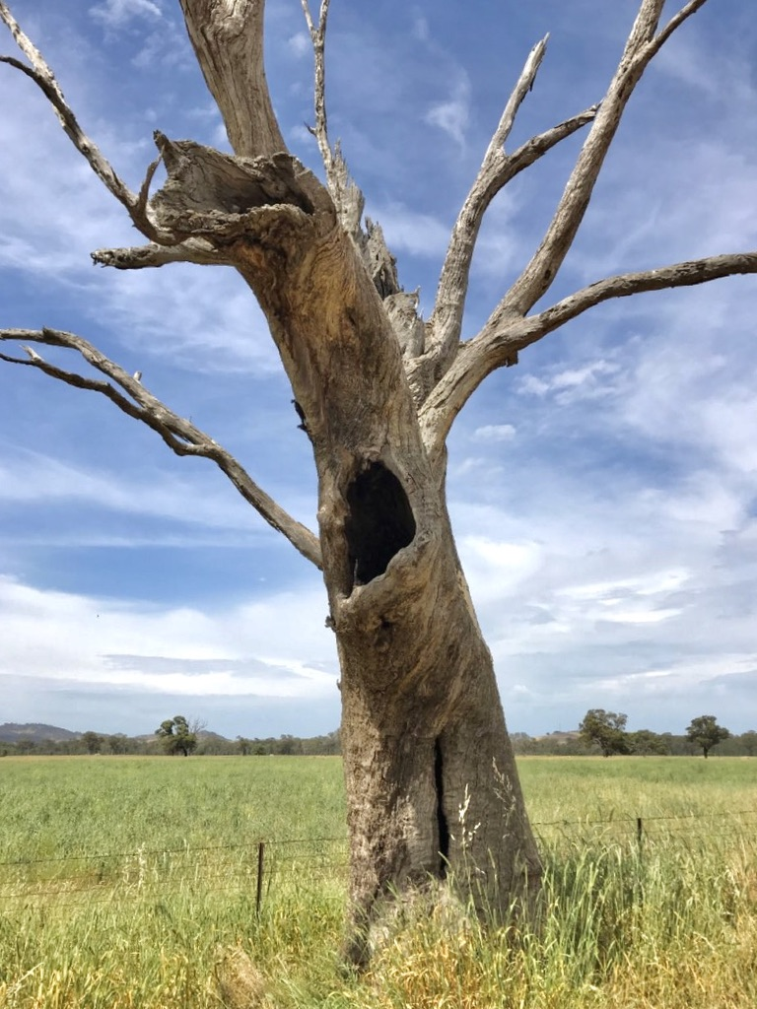
Figure 1 Plains country

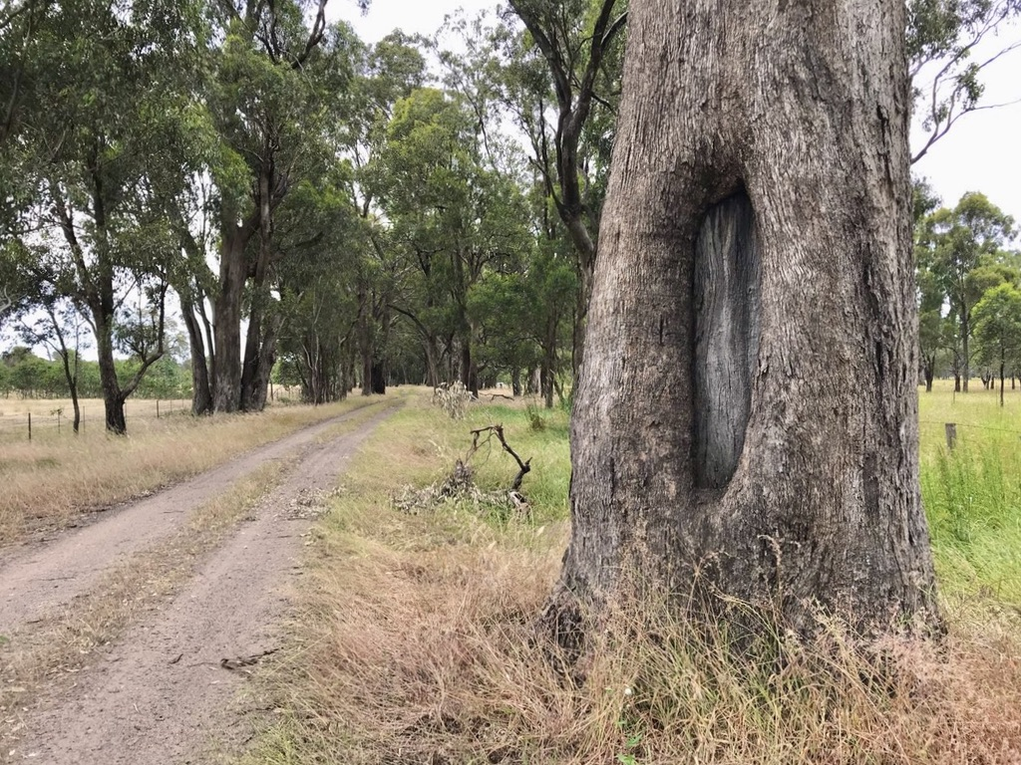
Figure 2 Roadside vegetation

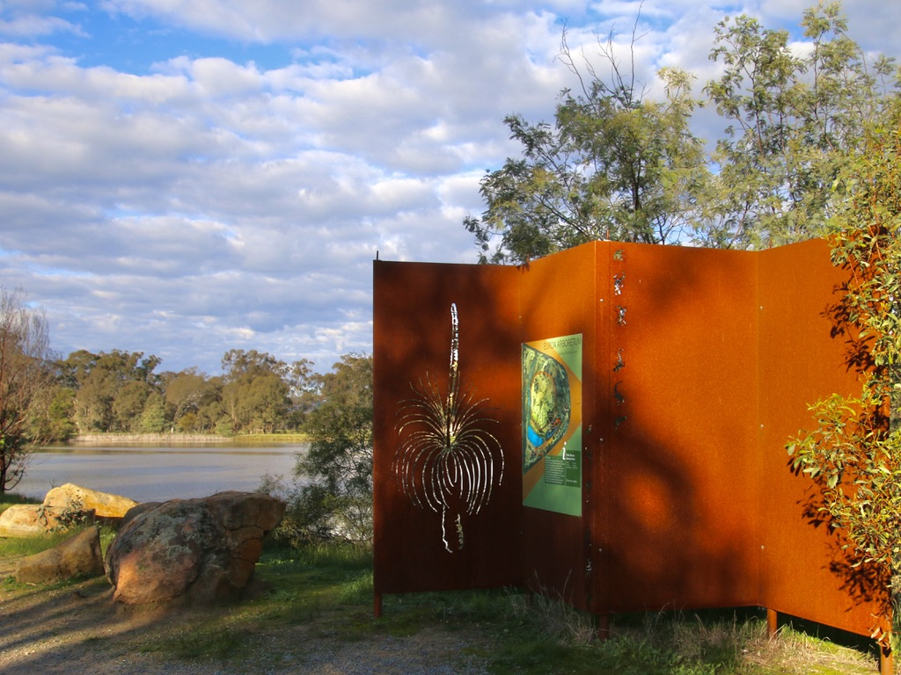
Figure 3 Euroa Arboretum

