Hub & Spoke Cycling Route

Route Name:
Avenel: Mangalore Aerodrome Loop

Mode:
Road cycling

Start / Finish locations:
Avenel Railway Station

Map:
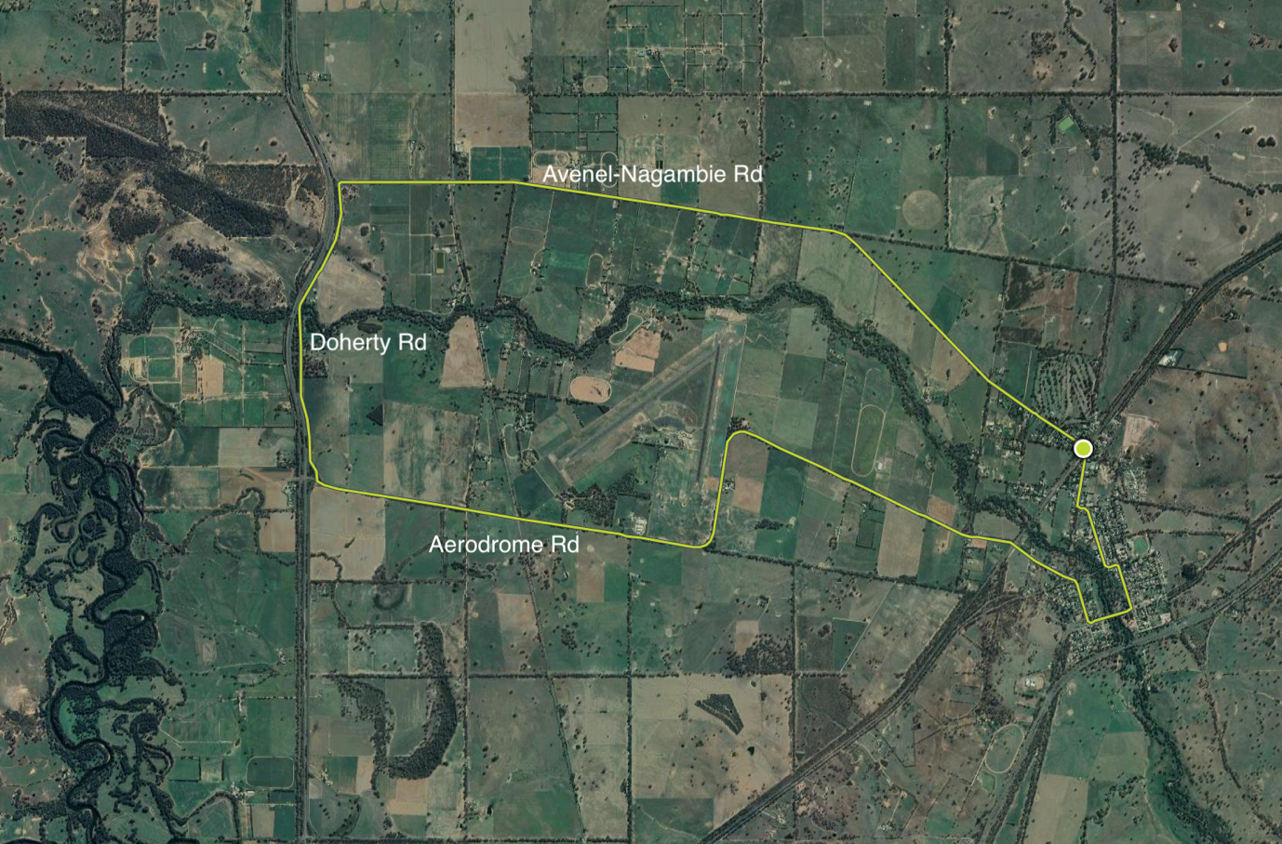

Difficulty:
Easy

Distance:
23km

Elevation:
136 – 155mm

Topography:
Flat

Surfaces:
Bitumen (smooth)
Description & Features:
A loop west past Mangalore aerodrome and back in through town
- River Red Gum agricultural plains country for cropping, grazing and horse studs.
- The route skirts Kestrel Helicopter Emergency Services and Mangalore Aerodrome.
- Runs parallel to Goulburn Valley Freeway for a short distance.
- Transits the historic Avenel Township.

Riding conditions:
The terrain is flat and exposed.

Options:
Clockwise or anti clockwise

Amenities (Avenel)
Car parking
BBQ
Fuel
Shops
Seating
Parkland
Playground
Picnic tables
Public toilets
Potable water
Accommodation
Historic features
Sports Reserves
Swimming Pool
Railway station

Cautions:
Snakes may be active
Mobile reception may be unreliable
Carry food, water, First Aid, be SunSmart
Be equipped for self-reliant riding

Anticlockwise Cues:
- Start Avenel-Nagambie Rd at Avenel Railway Station
- Left Doherty St
- Left Aerodrome Rd
- Straight Hughes St
- Left Old Hume Hwy (Henry St)
- Left Livingstone St
- Left Watson St
- Right Shelton St
- Left Jubilee Crescent
- Right Queen St
- Left Avenel-Nagambie Rd
- Avenel Railway Station

Photos:

