Link & Chain / Road Cycling Route

Route Name / Address:
Nagambie – Murchison Loop

Start / Finish locations:
Nagambie Railway Station Prentice St., Nagambie 3608

Mode:
Road bike (or any other)

Map (satellite):
GPS 36.785292° S 145.160579° E

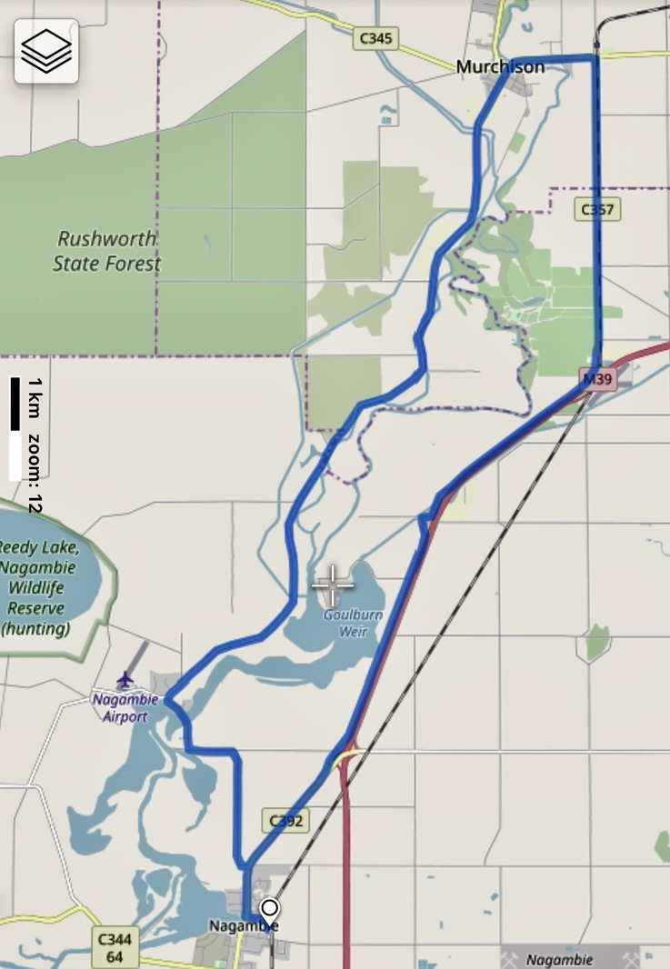
Difficulty:
Easy

Distance:
50km

Elevation:
211 – 145m

Topography:
Flat

Surfaces:
Sealed bitumen. Narrow around Kirwans Bridge and Goulburn Weir. Firm dirt shoulders. Murchison East has quite a bit of through traffic, but broad sealed shoulders. Morningside Rd has quite a bit of patching. It is the roughest section, not too bad.
If you wish to join the Rail Trail to Rushworth at Murchison (another 7 – 10km one way dependent on where you start), you will require a bike able to manage a gravel surface.

Description and Features:
Nagambie is well serviced, Murchison less so, but can offer accommodation, food and drink. This is flat river plains country. The route parallels the Goulburn River, Weir and major irrigation canals most of the way. There are various scenic sites, such as the aged Kirwans Bridge, broad vistas across prime grazing and cropping land, quality horse studs and wineries.

Riding conditions:
Generally, fairly low traffic during the week with more tourists about on the weekends. Some long straight stretches. There is little shelter from the elements on the road.

Options:
Include the Rail Trail to Rushworth.
Start anywhere
Clockwise or anti

Clockwise Cues:
Start Nagambie Railway Station
Straight Prentice St
Right High St
Left Lobbs Lane
Left Kirwans Bridge Rd
Right Goulburn Weir – Murchison Rd
Right High Rd
Right Wahring – Murchison Rd
Left Morningside Rd
Straight Hayshed Rd
Straight Grimwade Rd
Straight High St
Left Prentice St
Straight Nagambie Railway Station

Amenities:
Car parking
BBQ
Fuel
Shops
Winery
Seating
Parkland
Waterway
Playground
Picnic tables
Public toilets
Potable water
Walking tracks
Accommodation
Historic features
Sports Reserves
Swimming Pool
Railway stations
Directional signs
Information signs
Extension routes

Cautions:
Open water
Soft shoulders
Limbs may fall
Embankments
Uneven ground
Slippery surfaces
Subject to flooding
Road surfaces vary
Snakes may be active
Beware of vehicle traffic
Mobile reception may be unreliable
No potable water outside townships
Carry food, water, First Aid, be SunSmart
Be equipped for self-reliant riding

Restrictions:
Take rubbish with you
Historic relics are protected
Native flora and fauna are protected
Riders must use formed roads only

Photos:
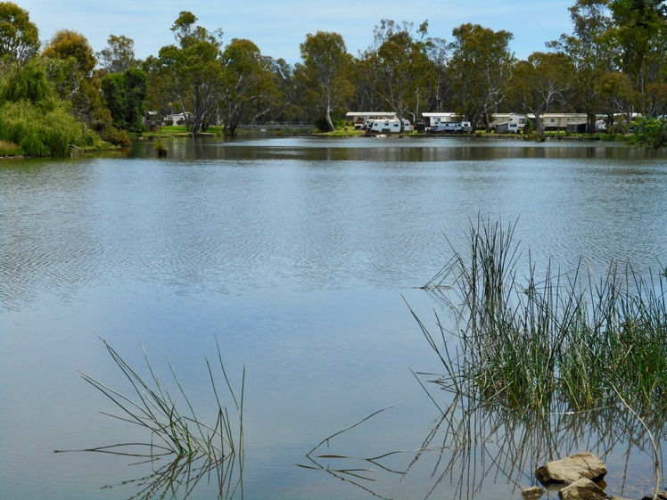
Figure 1 Plenty of accommodation at Nagambie Lake
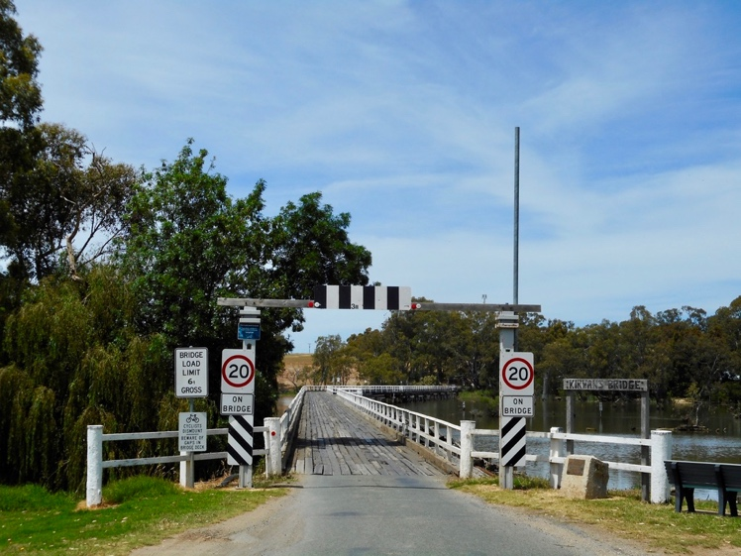
Figure 2 Kirwans Bridge

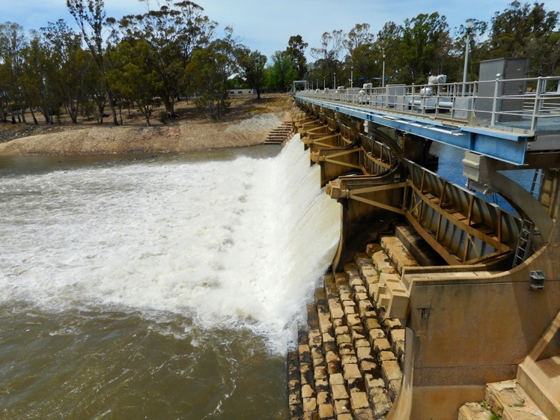
Figure 3 Goulburn Weir
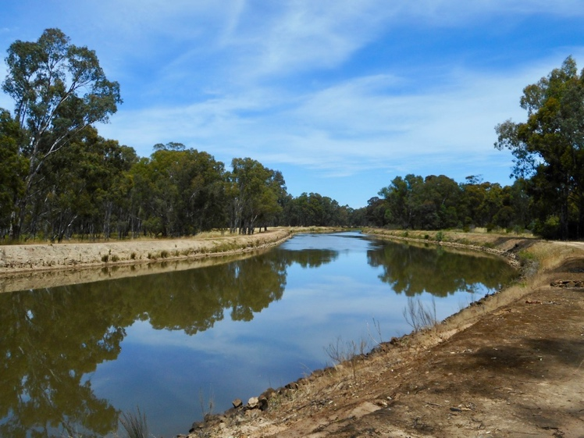
Figure 4 Stuart Murray Canal

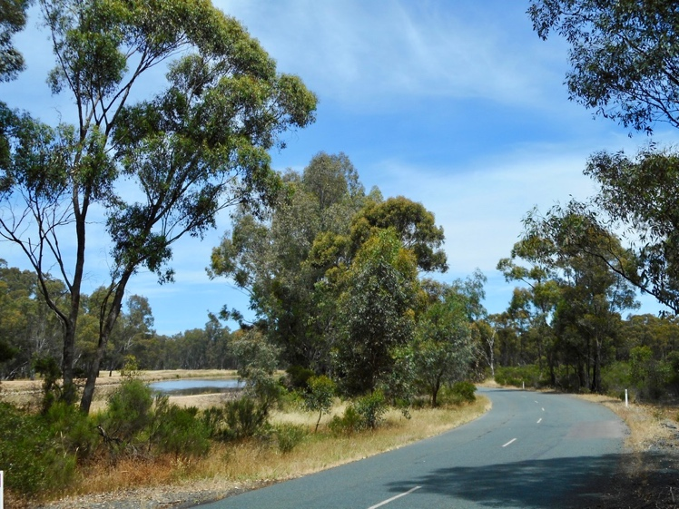
Figure 5 Generally good road surfaces

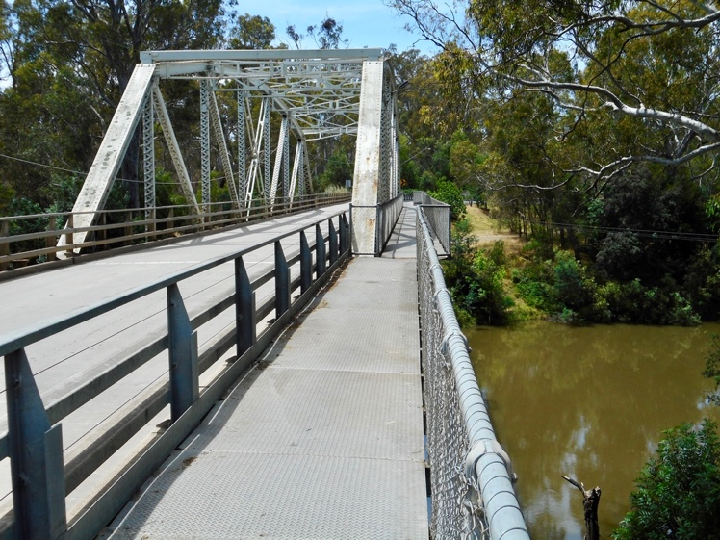
Figure 6 Goulburn River bridge, Murchison

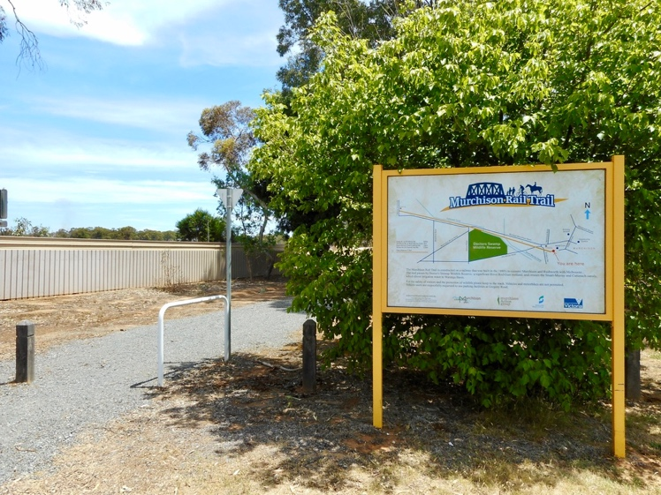
Figure 7 Murchison - Rushworth Rail Trail

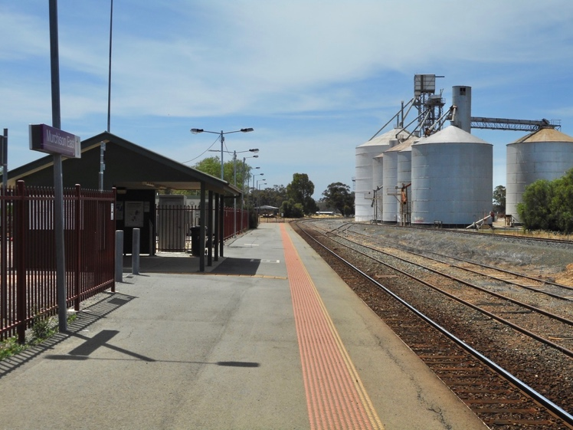
Figure 8 Murchison East railway station (Rail Trail start)

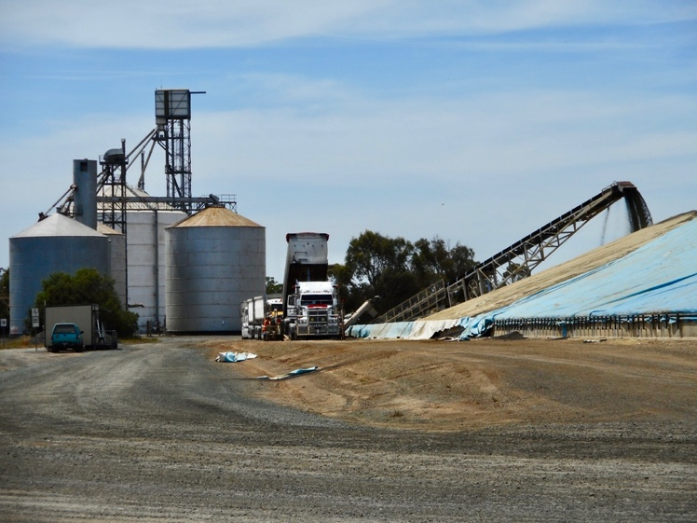
Figure 9 Grain stack Murchison East
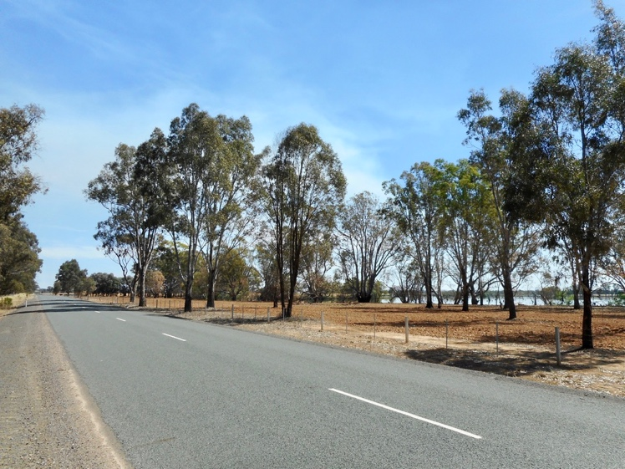
Figure 10 Long and straight: Hayshed Rd.

